What's the most efficient and best way to travel in New Zealand?

First way to travel would be to travel via backpacker tours which are essentially buses that offer a hop-on/hop-off service. These buses are very common and tend to embrace socializing with others with the help of the driver for starting up ice breaker games and trivias. These buses have 2 different types of options there is the Kiwi experience bus that attracts younger people from the age range of 18 - 30 years old. Then you have the bus called the stray travel that picks up older travelers that are not into the partying setting.

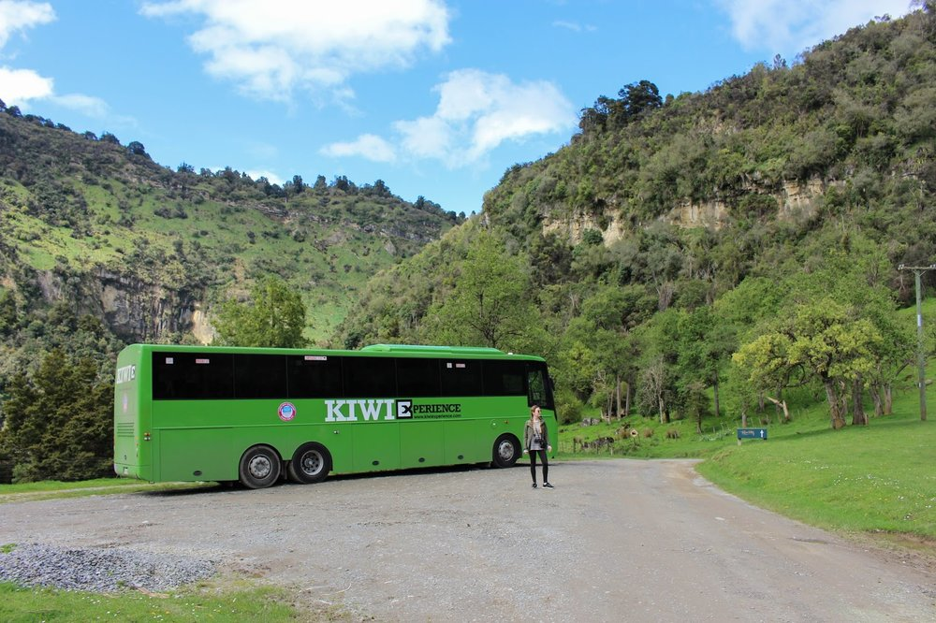

The other elite way of traveling would be via train, though its not the cheapest way of travel it will still help you get around quickly and allows you to sit and see the big windows for photos. Trains typically are above the price point of $100 per ticket for child and adult but the upclose scenery is well worth it.

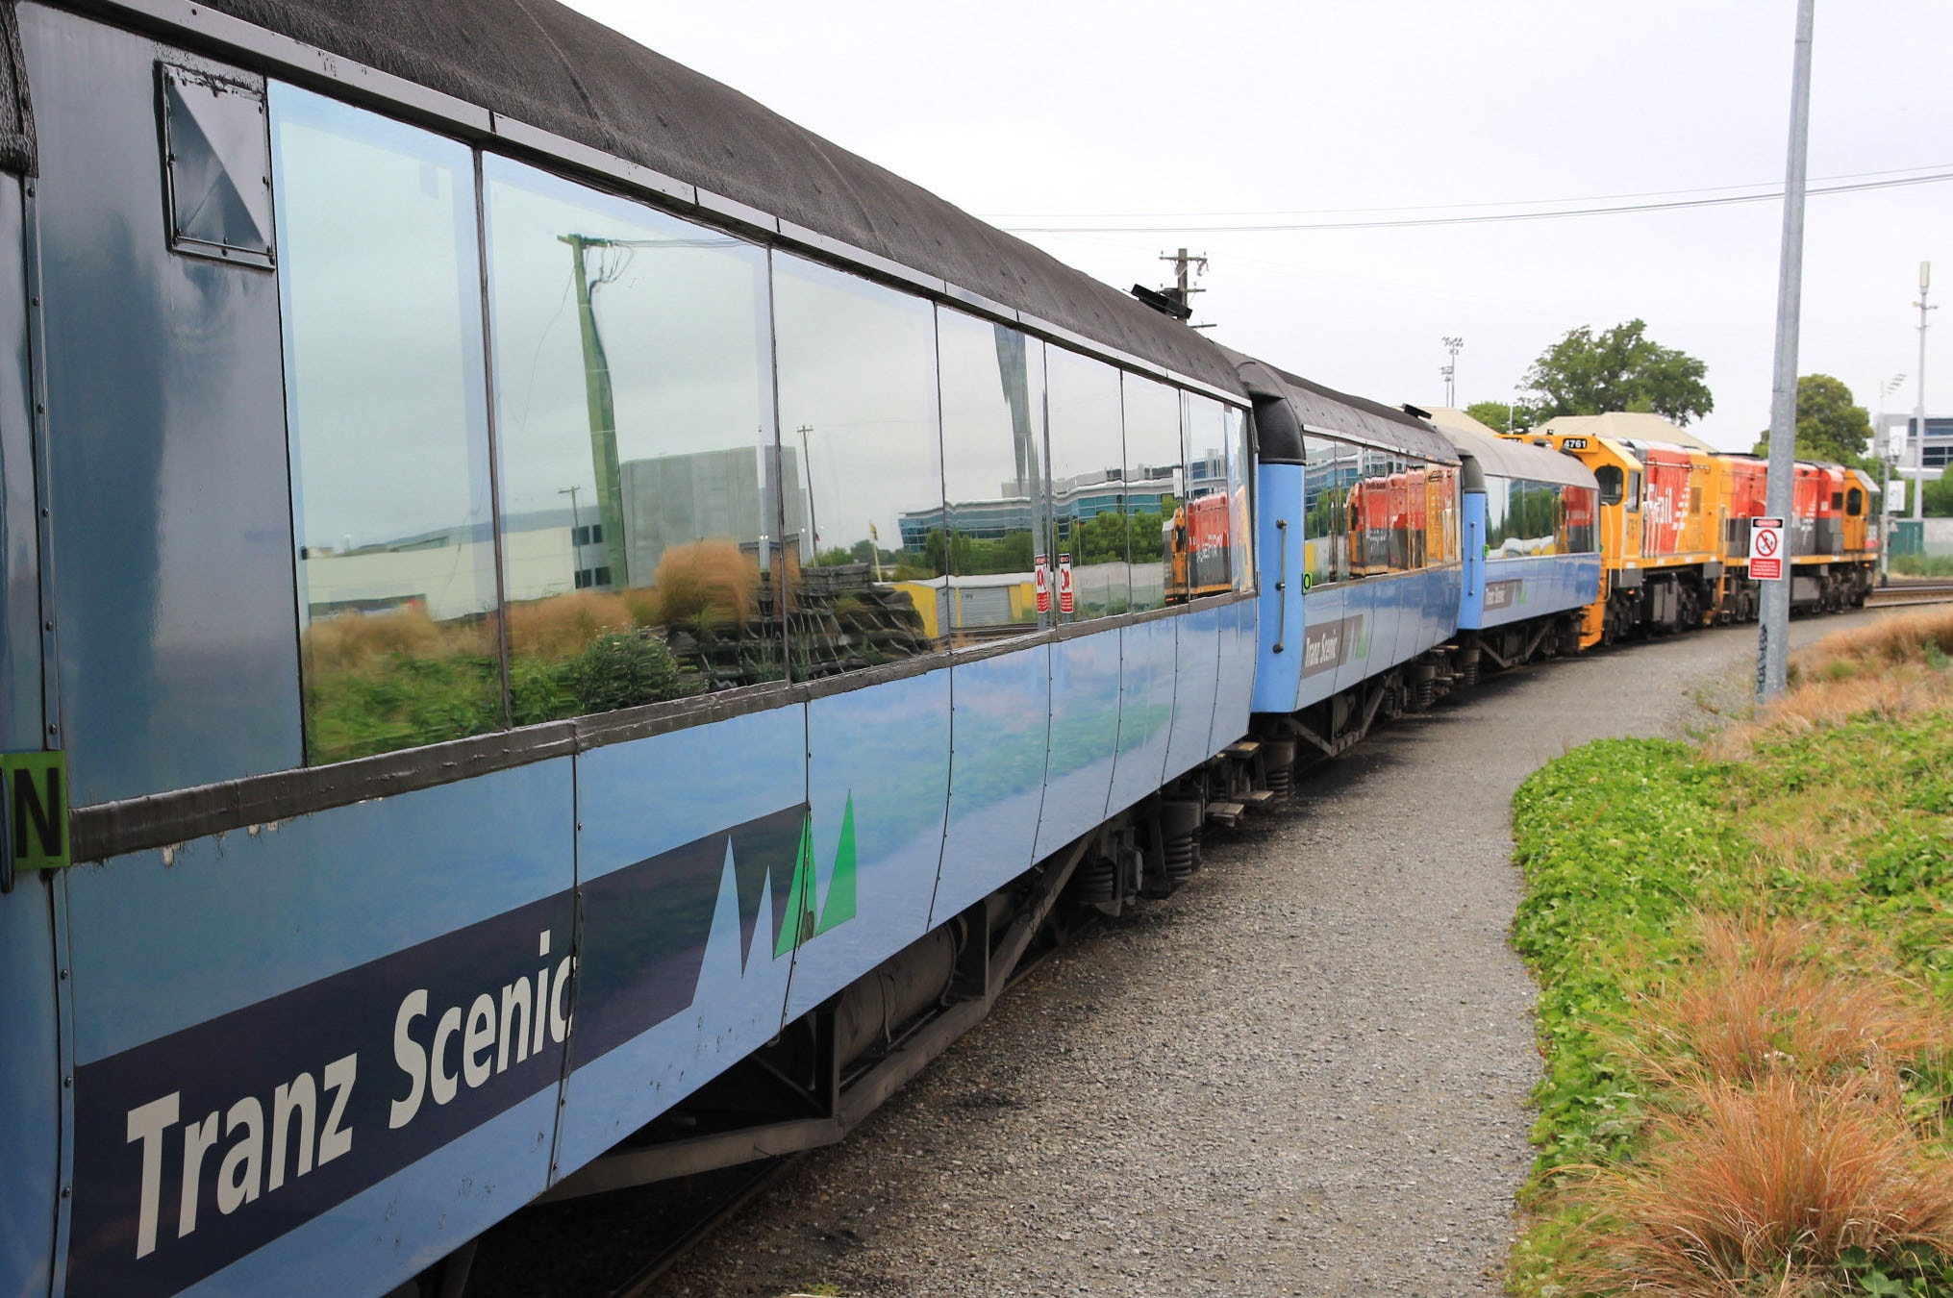

The last option for travel would be by car rental or campervans. Rentals are good if you want to stay out of the way of others and just want to enjoy the quite peaceful roads all by yourself or with family/friends. During these times of Covid-19 this would also be the best route. The only issue that might be a problem is factoring in different fees and rates depending on where you want to pick up your vehicle from. Prices begin at $25.00 per week and also begin at $16.50 per month These prices still beat your average normal day to day prices for regular car rentals so you don’t have that much to worry about.

